

Dr. Helen, Bradley inc.

2018-12-28

Dr. Bradley

Unit 2310 Box 1872, DPO AP 58527

Phone: 5118078901

Fax: 6491307221

**Re:** Angel, Faulkner

**PHN:** 9723525789

**Birthdate:** 31-Oct-1945

**Address:** 51051 Serrano Club Apt. 893, Youngfurt, PA 20758

**Patient number:** 3503532248

To Whom It May Concern:

This is a medical letter to state the above patient is pregnant with expected delivery date of 26-Jun-2025. Hoping this information is satisfactory for your requirements.

Thank you.

Sincerely,

Dr. Helen, Bradley

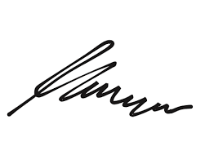

FRCS© NCMP

Clinical Assistant Professor, UBC

Department of Obstetrics and Gynecology SMH